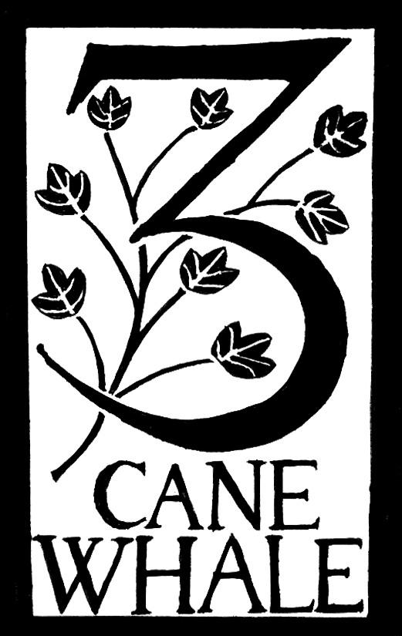

Three Cane Whale

Multi-instrumental acoustic trio Three Cane Whale comprises Alex Vann (Spiro), Pete Judge (Get The Blessing) and Paul Bradley (Scottish Dance Theatre). It combines the influences of folk, minimalism, classical and film music to produce something “fascinating, remarkable, and impressively original” (The Guardian), in which “the aroma of muddy leaves and old nettles is almost tangible” (The Observer).

The band’s eponymous debut album was recorded live in an eighteenth-century Bristol church, and chosen by Cerys Matthews as one of her ‘Top Five Modern Folk Albums’ (Sunday Telegraph). Second album Holts and Hovers was recorded in 20 different locations, including churches, chapels, a greenwood barn, an allotment shed, the top of a Welsh waterfall, and the underside of a Bristol flyover. It was fRoots Editor’s Choice Album Of The Year 2013, one of the ‘Hidden Gems Of 2013’ in The Observer, and one of Acoustic Guitarist magazine's '20 Essential Folk Albums'.

2016's "Palimpsest" album was recorded in Real World Studios in Wiltshire, with Adrian Utley from the band Portishead producing, and guest musicians Estonian violinist Maarja Nuut and British cellist James Gow, with artwork by Dorset's Little Toller press (best-known for their gorgeous editions of old and new nature writing classics). "Palimpsest" received 4-star reviews in The Guardian, The Independent On Sunday, The FT, The Irish Times, The Mail On Sunday, Songlines, and The Telegraph, and was a 5-star Playlist Choice in fRoots.

At the end of 2016, "Three Cane Whale: Live At The Old Barn, Kelston Roundhill" was chosen as the inaugural release on Kelston Records.

Music by the band has appeared on BBC Radios 3, 4 and 6Music, as well as BBC TV's Springwatch, Countryfile and The One Show, and the soundtrack to 2016's independent feature-film "Brown Willy" ("Cornwall's answer to Withnail & I"). In 2017, the band is collaborating with 10 filmmakers and visual artists on short films to accompany live performances, and will be touring the results throughout the UK.

Three Cane Whale are:
Alex Vann – mandolin, bowed psaltery, zither, bouzouki, tenor banjo, hammered dulcimer
Pete Judge – trumpet, cornet, tenor horn, harmonium, dulcitone, lyre, chimes, glockenspiels
Paul Bradley – acoustic guitar, miniature harp

www.threecanewhale.com FB: threecanewhale twitter: @3canewhale

Reviews:
"Live At The Old Barn, Kelston Roundhill" (2016)
Tthe perfect introduction to the unique and quietly impassioned music of 3CW" (fRoots)

"Palimpsest" (2016)
‘Exquisite, elegant, atmospheric and charmingly quirky. 4 stars' (Robin Denselow, The Guardian)

‘Quiet but compellingly emotional music containing melodies of real beauty. 5 stars’ (fRoots)

‘A beautiful, contemplative set, another jewel to add to the musical box of miniature treasures that is Three Cane Whale. 4 stars” (Tim Cumming, Songlines)

‘This charming album is an elegant treat. 4 stars’ (The Telegraph, Best Folk Music Albums Of 2016)

‘Uniformly gorgeous…rustic but sophisticated. 4 stars’ (The Mail On Sunday)

‘Its sense of rural enchantment is unwavering’ (Neil Spencer, The Observer)

‘Their delicate acoustic constructions combine ancient folk and contemporary classical ideas to weave an entirely original new musical tradition’ (Bristol 24/7)

‘These multi-instrumentalists are the living heart of what folk music should be' (RootsWorld)

"Holts and Hovers" (2013)
‘Fascinating and remarkable. 4 stars’ (Robin Denselow, The Guardian)

The aroma of muddy leaves and old nettles is almost tangible. A delight’ (Neil Spencer, The Observer)

‘Like otters – darting, mercurial, sudden, sinuous. 4 stars’ (fRoots)

‘Marvellous. 5 stars’ (The Independent)

‘Quietly, utterly enchanting’ (Songlines)

‘Astonishingly eclectic…atmospheric, beautiful and haunting’ (EDS Winter 2013)

"Three Cane Whale" (2011)
‘Perfect. A glorious adventure into new folk’ (Cerys Matthews, BBC 6Radio / Sunday Telegraph)

‘Ever-inventive’ (Fiona Talkington, BBC Radio 3’s Late Junction)

‘Elegant and atmospheric. An impressively original debut. Four stars’ (Robin Denselow, The Guardian)

‘An air of enchanted impressionism. Album Of The Week’ (Tim Cumming, The Independent)

‘A hazy shimmer. Four stars’ (David Honigmann, Financial Times)

‘Unusual and enchanting. Waves of delightfully understated melody and rhythm. A distinctive pleasure. Four stars’ (The Irish Times)

‘Think of the way light refracts through a raindrop. Intricate, atmospheric and simply beautiful. Four stars” (R2)

‘They bestride not just centuries of instrumentation but genres. Mesmerising’ (Q)

